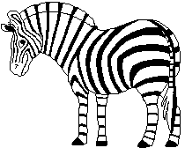
ANIMAL ADAPTATIONS
Select and animal that interests you and research how it has adapted to suit its environment.
Physical Description:
Habitat:

Climate:

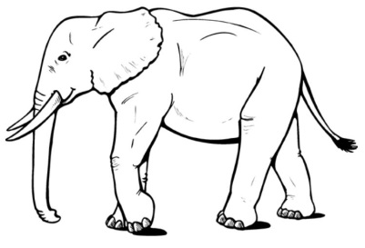
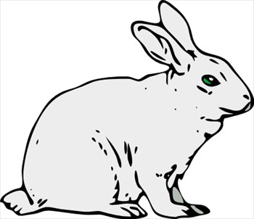
Animal:

Diet:
Special Features:
Adaptations:

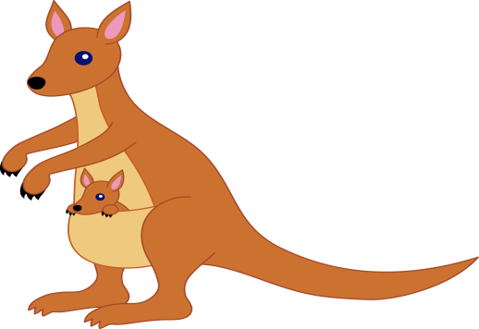

Use this information to create a computer presentation to educate your classmates about the animal you chose.
Due Date:

